Lab 0 - Basic Arduino Commands

ME 451 - Introduction to Instrumentation and Measurement Systems, Spring 2019

### Materials

The following materials are required for this lab:

* Your laptop (Windows/Mac)
* Lab 0 kit

### Lab Resources

* [Arduino Code Reference](https://drive.google.com/a/oregonstate.edu/file/d/1_nkmKWya7oSzES_PaZas_3Ql6bNMBv0I/view?usp=drivesdk)
* [ME451 Basic Electronics Guide](https://docs.google.com/document/d/1Jj0GTNjAzPEXTHfg56qW23pFiFHA6RBilS7b9N5RSIU/edit?usp=sharing)
* [Arduino Language Reference](https://www.arduino.cc/reference/en/)

### Lab Directions

This is a *1 day* lab.

1. First, we will need to download the relevant software for Arduinos.
   1. Go to [arduino.cc](https://www.arduino.cc/), select software, and download the relevant Arduino IDE package for your laptop.
   2. To make sure that everything works correctly, we are going to upload a simple program to your arduino. Open [File] -> [Examples] -> [01.Basics] -> Blink
      1. **Discussion Question 1:** Take a look at the code. What does it do, and what pin does it utilize?
      2. Edit the program to make the light blink every half a second. Upload the code to your arduino.
      3. Demonstrate the working program to your TA for Signoff 2.
2. Now it’s time to start implementing an actual circuit. The first sensor we will use is a button.
   1. Set up the following circuit: a button with a pull-up resistor.

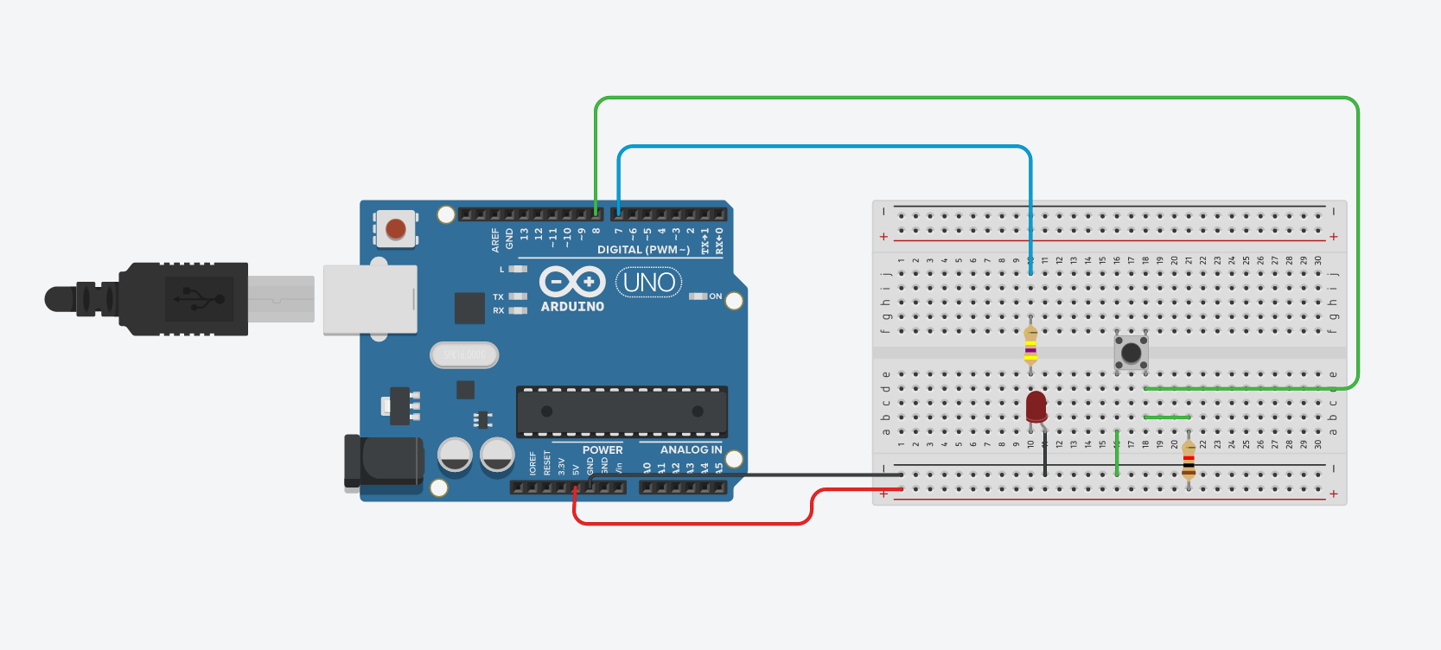

* 1. Using the provided reference materials, write code to make the arduino sense the state of the button.
     1. **Discussion Question 2:** Which command will you use to read in a button?
  2. Let’s add an LED to the breadboard and hook it up to the arduino (check your electronics reference guide for make sure that you do it right).
  3. Using the provided reference materials again, write code to make the arduino turn the LED on when the button is pressed, and off when it is released.
     1. Demonstrate a working implementation to your TA for Signoff 3.

1. It’s time that we moved on to another sensor. Keep the LED, but remove the button circuit.
   1. Set up the following circuit for your light sensor, however you will need to choose which pins to connect the LED and light sensor to.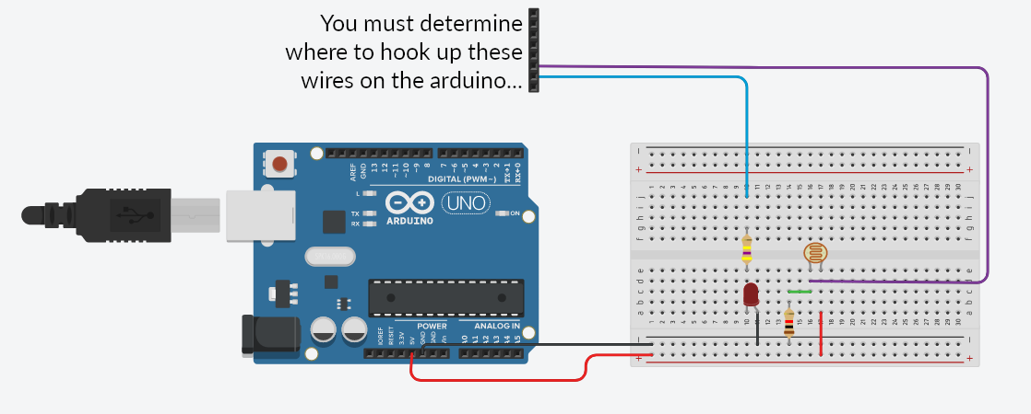
   2. Using the provided reference materials again, write code to make the arduino sense the state of the light sensor.
      1. **Discussion Question 3:** Which command will you use to read in the light sensor?
   3. One last time, using the provided reference materials, write code to make the arduino dim the light according to the light level that the light sensor senses.
      1. *hint:* the read and write commands of the command you will use to read the light sensor utilize different ranges, and so you will need to accomodate for that in your code. Check out the [map()](https://www.arduino.cc/reference/en/language/functions/math/map/) to go between the different ranges.
      2. Demonstrate a working implementation to your TA for Signoff 4.
2. Make sure to clean up your space and get all of your signoffs.

### Group Names:

(in pen)

### Lab 0 Sign-offs

Each signoff is worth 2 points. Half credit sign-offs may be given for incomplete work, an incorrect implementation, or a correct implementation with poor presentation.

1. _______ Brought the correct lab materials to the lab.
2. _______ Successfully uploaded sample code to the arduino.
3. _______ Demonstrated button implementation.
4. _______ Demonstrated light sensor implementation.

**TA Signature**: ________________________________________________ **Date**:___________

### Post Lab Questions

1. Describe what the setup and loop functions do in an Arduino sketch.
2. When the arduino reads in a value, it will represent it as a number. What is the range of values that the arduino will use for the digitalread and analogread functions? What device on the arduino board actually reads in voltage for the analog pins? What is the range that the analogWrite command can take in?
3. What are pull-up and pull-down resistors? Draw the electrical schematic for both setups and describe why they are necessary.

### Note: For this lab only, you will have to show your lab report to your lab TA for a Lab 1 signoff. For all future labs, you will submit your lab reports on Gradescope.